NAAN MUDHALVAN

TITLE : WORDPRESS CREATION

USER NAME : 67F6CF7AEAE3B5CBCBC43CBB46746FBB

1.open the facebook login

2.create a business acout page

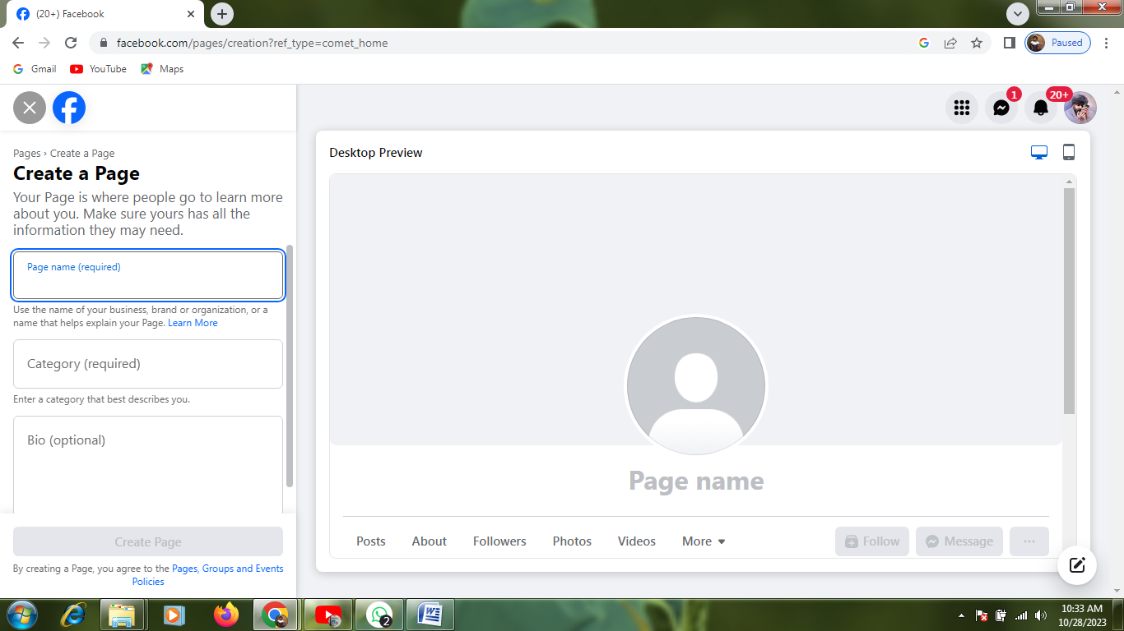

3.upload the details

(1) images

(2) contact details and description writing

For example:

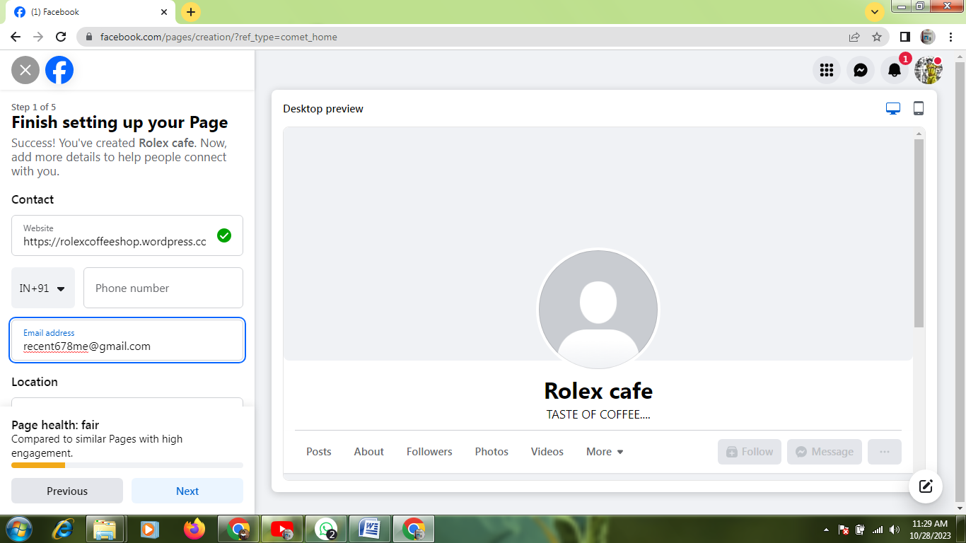

4.business home page created

